**Hello World RESTful Web Service**

**Step-1: created all these according to doc**

**Method:** GET  
**URL:** /hello  
**Controller:** com.cognizant.spring-learn.controller.HelloController  
**Method Signature:** public String sayHello()  
**Method Implementation:** return hard coded string "Hello World!!"  
**Sample Request**: http://localhost:8083/hello  
**Sample Response:** Hello World!! 

**Step-2:**

**HelloController.java**

**package** com.cognizant.spring_learn.controller;

**import** org.slf4j.Logger;

**import** org.slf4j.LoggerFactory;

**import** org.springframework.web.bind.annotation.GetMapping;

**import** org.springframework.web.bind.annotation.RestController;

@RestController

**public** **class** HelloController {

**private** **static** **final** Logger ***LOGGER*** = LoggerFactory.*getLogger*(HelloController.**class**);

@GetMapping("/hello")

**public** String sayHello() {

***LOGGER***.info("START: sayHello()");

String message = "Hello World!!";

***LOGGER***.info("END: sayHello()");

**return** message;

}

}

**Output:**

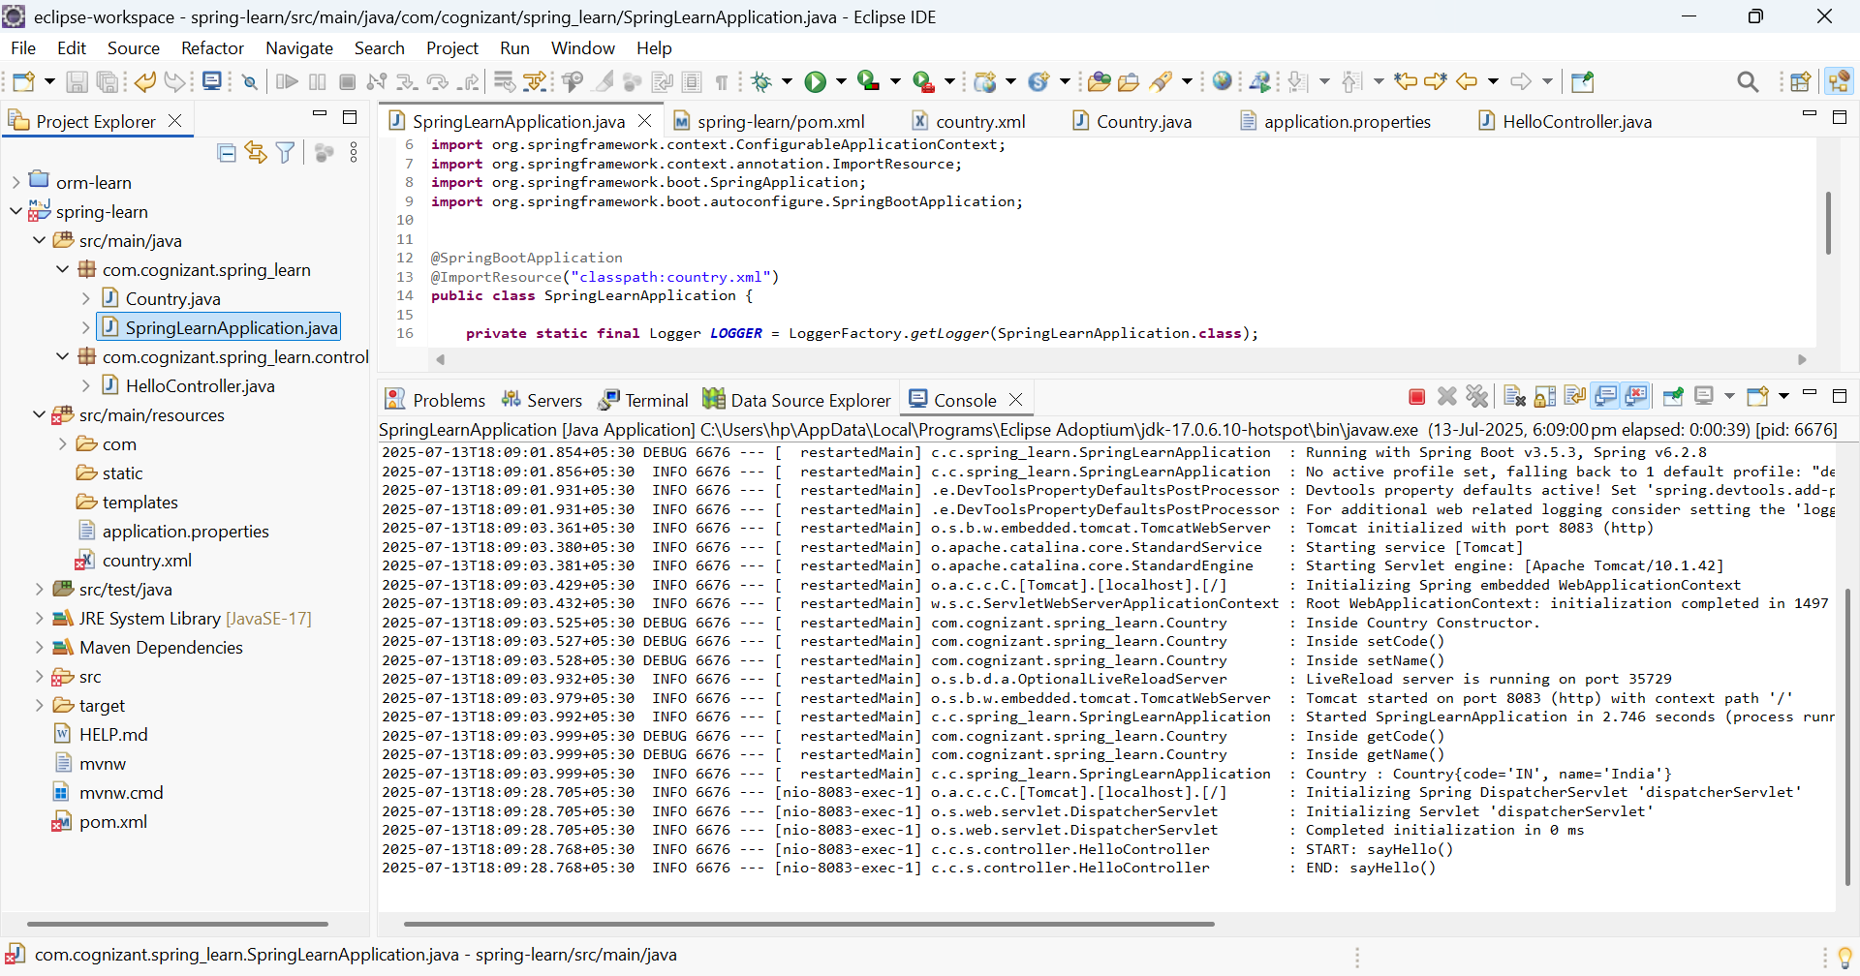

The URL **http://localhost:8083/hello** is used in chrome browser.

